*Name: Arjun Mehta*

*K036*

*B. Tech CSE Cybersecurity*

*Semester 4*

**Probability And Statistics Lab 3**

**Practice:**

head(airquality)

plot(airquality$Ozone, airquality$Month, main="Relation Between Ozone",

xlab="Ozone Concentration", ylab="Month of Observation", col="blue", pch=21)

plot(airquality$Month, type="p", main="Line Plot",

xlab="X-axis Label", ylab="Yaxis Label", col="red" ,pch=15)

a <- c(17,32,8,53,1)

b <- c("mumbai","pune","delhi","banglore","hydrabad")

barplot(a,names.arg=b, main="Bar-Chart", col="green")

d=table(airquality$Month)

d

barplot(d,names.arg=c(5:9), main="Bar-Chart", col="grey" )

hist(airquality$Temp, main="LA Guardia Airport's Maximum Temp.(Daily)",

xlab="Temp. (Fah)",xlim = c(50,125), col="yellow" , freq = TRUE)

boxplot(mtcars$disp~mtcars$gear)

summary(mtcars)

geeks <- c(23,56,20,63)

labels <- c("mumbai","pune","delhi","banglore")

pie(geeks,labels)

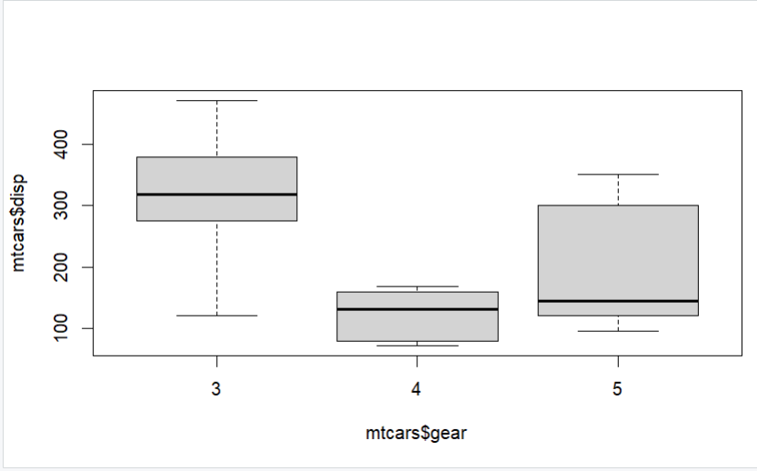

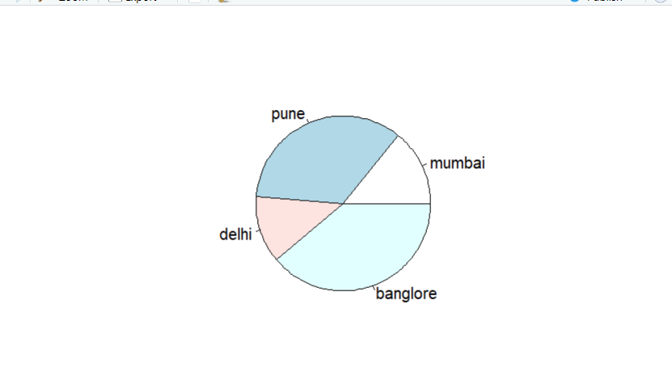

Q1)

Scatter Plot Arjun Mehta K036

plot(cars$speed, cars$dist, main="Speed vs Distance",

xlab="Speed (mph)", ylab="Distance (ft)", pch=19, col="blue")

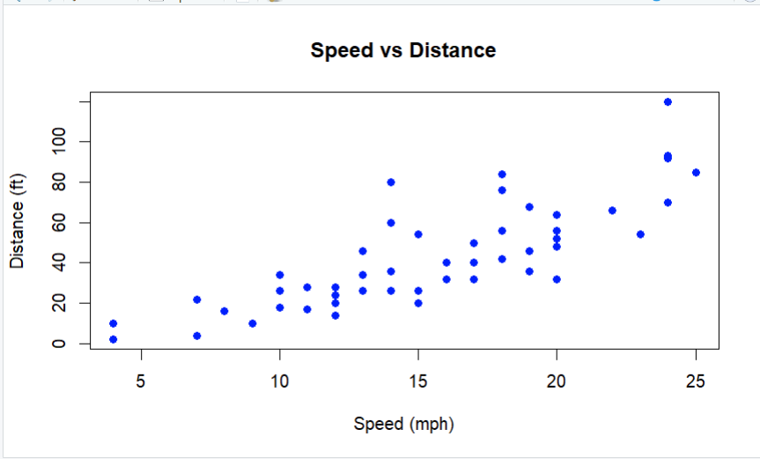

Q2

Line Plot Arjun Mehta K036

months <- seq(from=1, to=12, by=1)

temperature <- c(30, 32, 35, 40, 45, 50, 55, 60, 58, 53, 45, 35)

plot(months, temperature, type="o",

main="Monthly Average Temperature",

xlab="Month",

ylab="Temperature (°C)",

col="red",

lwd=2,

pch=16)

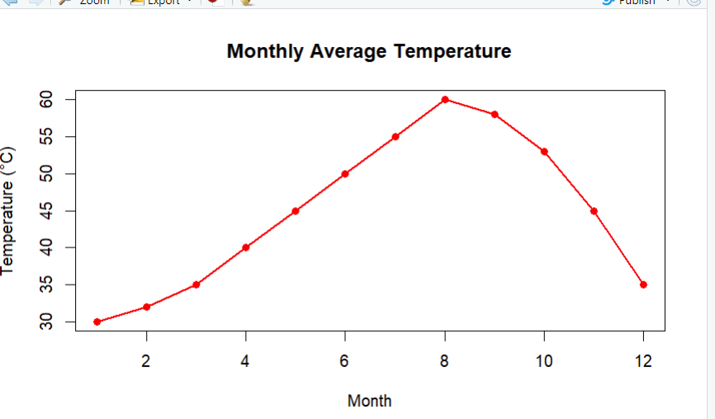

Q3

Bar Plot Arjun Mehta K036

cylinder_count <- table(mtcars$cyl)

barplot(cylinder_count, main="Number of Cars by Cylinder Type",

xlab="Number of Cylinders", ylab="Count of Cars",

col="lightblue")

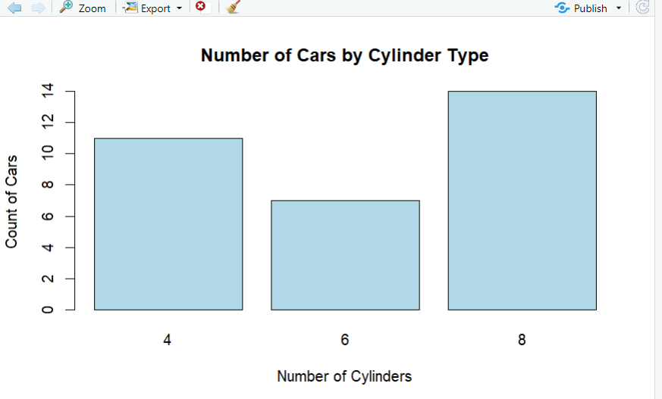

Q4

Histogram Arjun Mehta K036

cylinder_count <- table(mtcars$cyl)

barplot(cylinder_count, main="Number of Cars by Cylinder Type",

xlab="Number of Cylinders", ylab="Count of Cars",

col="lightblue")

